

eServe System
Design Spec

September 2014 – June 2015

Project Professor: Mr.Gilles
Students: Dawn, Jyoti, Tsun

Master of Software Engineering
Seattle University

Revision History
Date | Revision | Description | Author
111/21/2014 | 1.0 | Creation of document | Dawn Wang

Table of Contents
1. Introduction 1
1.1. Purpose 1
1.2. Scope 1
2. System Environment 2
2.1. Overview 2
2.2. Development Software 2
2.3. Language 2
2.4. Backend database 3
2.5. eServe website 3
3. Architecture 3
3.1. Overview 3
3.2. Advantage of 3-tiers architecture 3
3.3. eServe 3-tiers structure 3
4. Maintainability, Extensibility, Scalability, Usability and Security 4
4.1. Overview 4
4.2. Maintainability 4
4.3. Extensibility 5
4.4. Scalability 5
4.5. Usability 5
4.6. Security 5
5. Others 6
5.1. Source Control and Project Management 6

Introduction

Purpose
eServe is a web application to manage the volunteer opportunities and process for Seattle University. The purpose of this document is to describe the eServe system design, architecture and workflow. Also will detail the implementation of eServe.

Scope
The scope of this document is to define the technical design of the eServe, which includes:
- Technologies in System
- Architecture
- Maintainability, Extendibility, Scalability, Usability and Security
- 4+1 views
- Others

System Environment

Overview

This section addresses technology information that is needed to develop the eServe system. As per Seattle University requirement – using Microsoft technologies and Cloud.

Development Software
eServe uses Visual Studio 2013 ASP.NET, for the web site development, which implements UI, Business layer and Data Access layer; uses SQL Azure for backend database development.
Since we use SQL Azure, team members can connect to the database from anywhere as long as has WIFI, no need to join a domain or connect to a corp network.
Below is the SQL Azure management portal and the end user using DBMS to connect to SQL Azure.
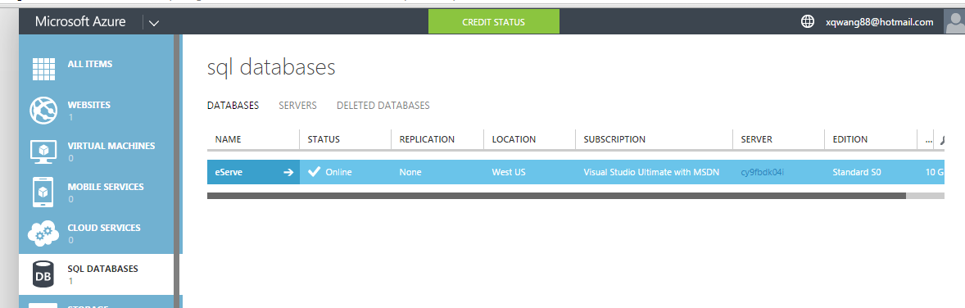
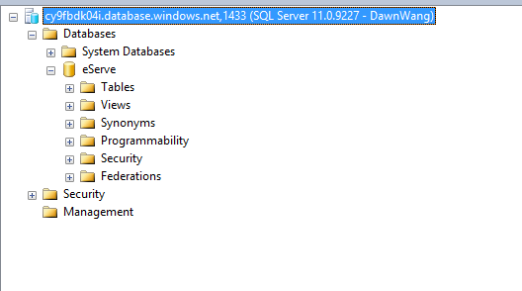

Language
UI: HTML, Javascript and CSS.
Business and Data Access layer: ASP.NET C#
Data Storage layer: SQL

Backend database
Backend database uses Microsoft SQL, in eServe is SQL Azure.

eServe website
eServe published website is hosted in Azure.

Architecture

Overview
eServe uses 3-tiers architecture for application development. eServe is web application, the 3-tiers are Client Tier – Browser, Middle Tier – Business logic and Data Storage Tier – Database.

Advantage of 3-tiers architecture
In this architecture, there is not any direct communication between the presentation and data access layers, everything must pass through business layer which is in the middle.
3-tier architecture is loose-coupling. The big advantage of a 3-tier system that the contents of any of the tiers/layers can be replaced without making any resultant changes in any of the others.
For example:
A change from one DBMS to other will only involve a change to the part in the data access layer.
A change in the UI, like web pages, will need only some changes in the components in the presentation layer.
Another big benefit is writing the presentation and business layered architecture in different languages, which is feasible to use different development teams to work on each. It means that only C# skills are required for data access layer and business layer, but for presentation layer only requires HTML, CSS and XLS skills. In the real industry, it’s easier to find a developer with skills, rather a developer having all of the skills.

eServe 3-tiers structure
In eServe, Presentation Tier uses HTML and CSS, Business Tier and Database Access Tier use C#, Data Storage layer uses SQL Azure. The following image is structure:

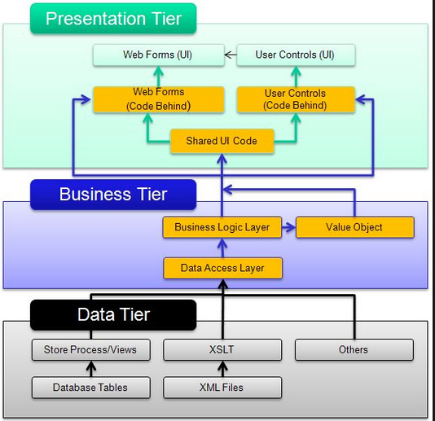

Maintainability, Extensibility, Scalability, Usability and Security

Overview
This section will describe those critical drivers of eServe design.

Maintainability
eServe uses 3-tier architectures, this provides big advantage of system maintenance. The system has very loose coupling, if need code modification in UI, it won’t affect business layer and database layer. Same logic, if database has some changes, UI doesn’t need move code around to coordinate with the changes.
Also, eServe system considers the continuous improvement - learning from the past in order to improve the ability to maintain systems, or improve reliability of systems based on maintenance experience.

Extensibility
eServe design and implementation take future growth into consideration. It is a systemic measure of the ability to extend a system and the level of effort required to implement the extension. Extensions can be through the addition of new functionality or through modification of existing functionality. The central theme is to provide for change – typically enhancements – while minimizing impact to existing system functions.
eServe 3-tiers architecture design is loose coupling, and also, we make each object and each function as small as possible.

Scalability
eServe is a web application with backend SQL database in Azure. Scale website and database become extremely straightforward.
For increased performance and throughput for eServe websites on Microsoft Azure, we can use the Azure Management Portal to scale our Web Hosting Plan mode from Free to Shared, Basic, or Standard.
Scaling up on Azure Websites involves two related actions: changing our Web Hosting Plan mode to a higher level of service, and configuring certain settings after we have switched to the higher level of service. Both topics are covered in this article. Higher service tiers like Standard mode offer greater robustness and flexibility in determining how our resources on Azure are used.
Changing modes and configuring them is easily done in the Scale tab of the management portal. We can scale up or down as required. These changes take only seconds to apply and affect all websites in our Web Hosting Plan. They do not require our code to be changed or our applications to be redeployed.

Usability

eServe UI designs to support different devices, we use Responsive web design (RWD), resize the page based on device screen will happen automatically. Also the development uses bootstrap, this CSS is used very popular and widely, and tested in multi different browsers.
Also, 3-tiers design makes the adjustment for different device easily, since UI only uses HTML, JavaScript and CSS, this is common supported language for all devices and browsers.

Security
eServe has two different users, one is Seattle University student, Administrator and Faculty, the other is non-Seattle U accounts, like Community Partner. The system separate the login for both different accounts, if user has Seattle U log in ID, then the authentication will go through Seattle U portal, otherwise, it will go through eServe.

eServe UI data access all use Stored Procedures, no direct SQL statement in the UI code. This can prevent the SQL injection.

Responsive web design

Responsive web design (RWD)

Responsive web design (RWD) is an approach to web design aimed at crafting sites to provide an optimal viewing experience—easy reading and navigation with a minimum of resizing, panning, and scrolling—across a wide range of devices (from desktop computer monitors to mobile phones).

For example, the following two layouts:
- Full screen
- Small screen – with/without menu expanding

From the below images, we can see, when the page shrinks to smaller size, the menu and content in the page will get adjusted automatically.

Also, eServe uses bootstrap CSS library, this library is very popular, and used widely, and tested
cross multi browsers.

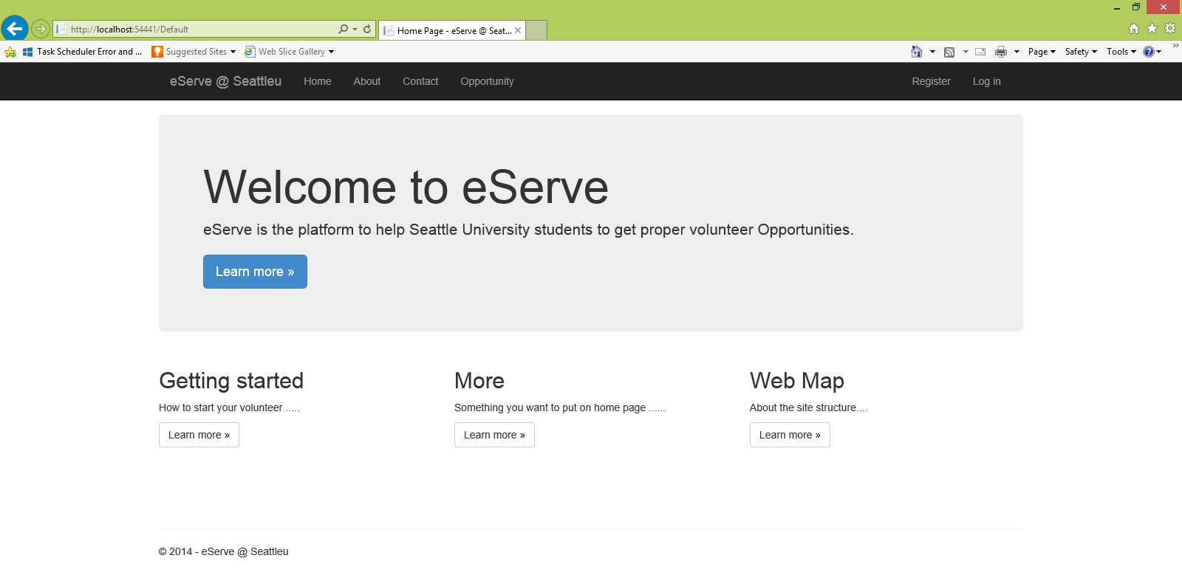
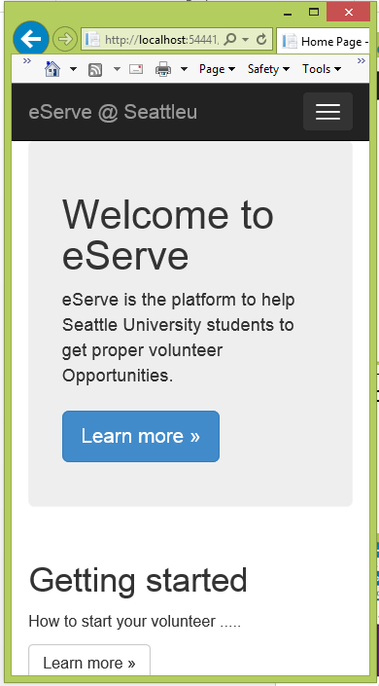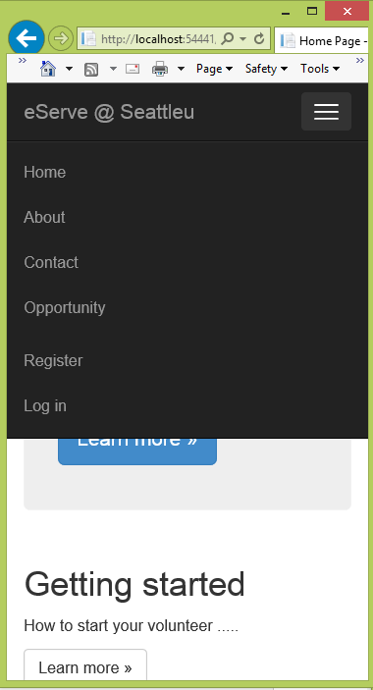

Others

Source Control and Project Management
eServe uses Visual Studio Online Team Foundation Server for Source Control and Project Management.

eServe uses Visual Studio as whole project portal, project team member can check the code, backlogs from anywhere as long as has WIFI.

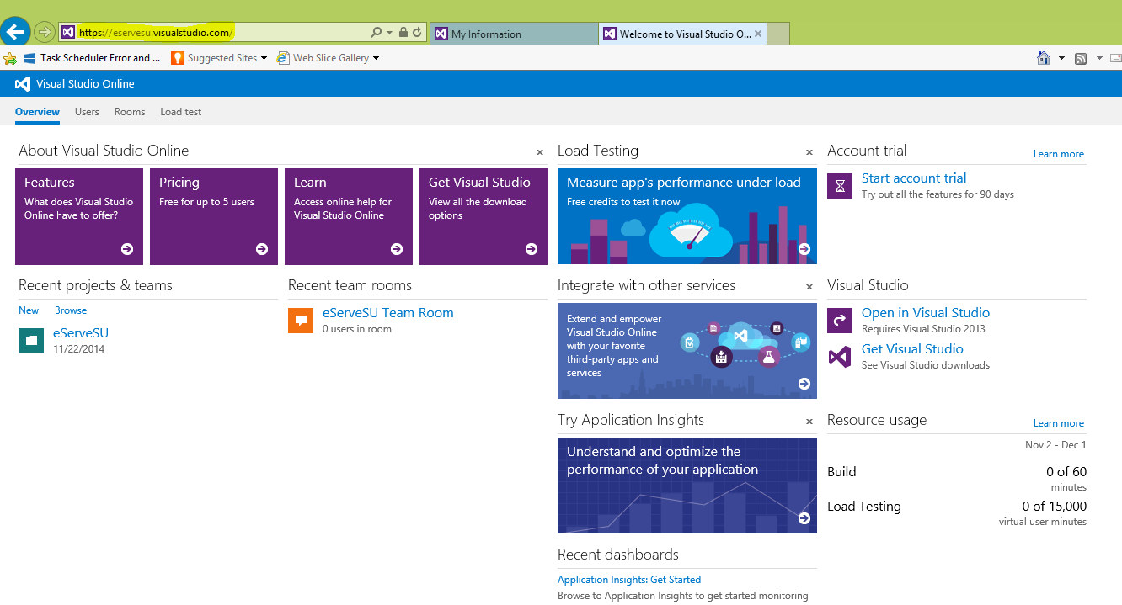

Process:
eServe creating software process is an approach that puts the user, rather than the system, at the center of the process. This philosophy, called user-centered design, incorporates user concerns and advocacy from the beginning of the design process and dictates that the needs of the user should be foremost in any design decisions.
During eServe development, we use Agile for project management. Team meets with end customer every two weeks, give the demo, collect feedback and new requirements, and decide what to change, what is the new development.
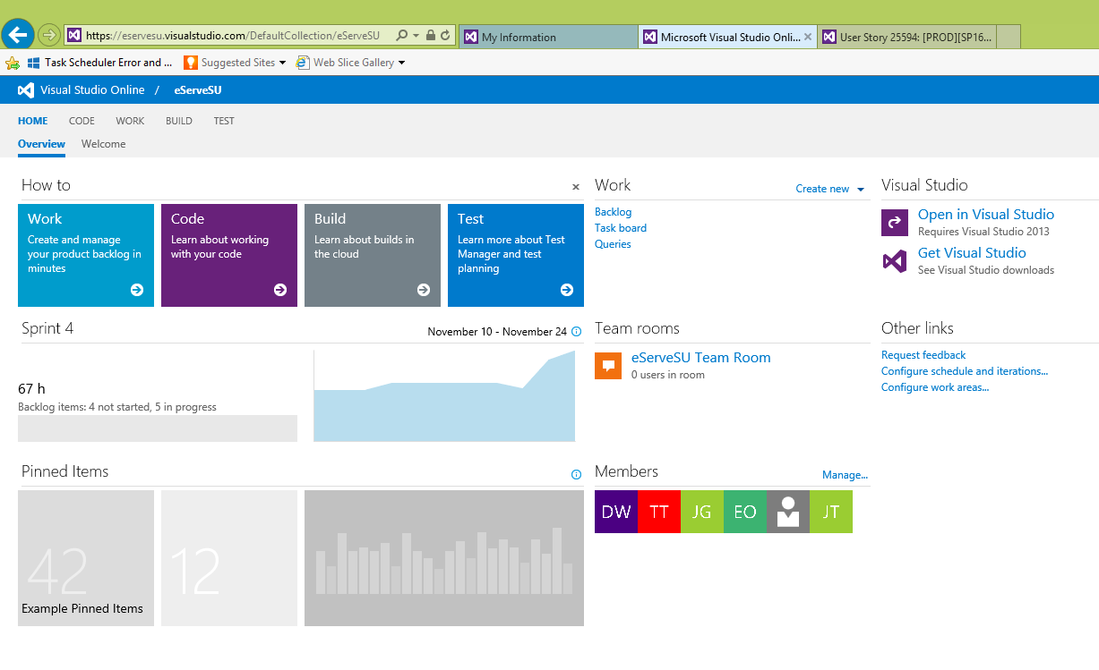

4+1 views for eServe
The following will show the 4+1 views.

Logic View:
The system is broken up into a three tiered system, with Front-end, Middle-Tier and Backend layers. This is a tried and true pattern for web-applications and I decided that this would fit with our system. I also made controls for the different actors, and subsystems for business logic and data access.

Front End
1. Student Controller (login/view/register) – This is the controller that handles all requests for the Client.
2. Faculty Controller (login/view) – This is the controller that handles all requests from Faculty.
3. Partner Controller (login/view) – This is the controller that handles all requests from Partner.
Middle Tier
1. Authorization – This systems validates who a user is.
2. Student Subsystem – This subsystem has the business logic for all the student information. It interfaces with the Student DB, Credit Subsystem, Matching Opportunities DB and Credit DB.
3. Faculty Subsystem – This subsystem has the business logic for all the faculty information. Faculties can upload matching request for students, and approve student’s credit request. It interfaces with the Credit Subsystem, Matching Opportunities DB and Credit DB.
4. Partner Subsystem – This system has he business logic for all the partner information. Partners can upload matching opportunities. It interfaces with Matching Opportunities DB.
Backend DB
1. Matching Opportunities DB – Stores a cached list of matching opportunities. This can help the performance.
External DB
1. Student DB – Stores a cached version of student information. This will allow for faster access.
2. Credit DB – Stores current and past credits of the students.

The following is Logic View.

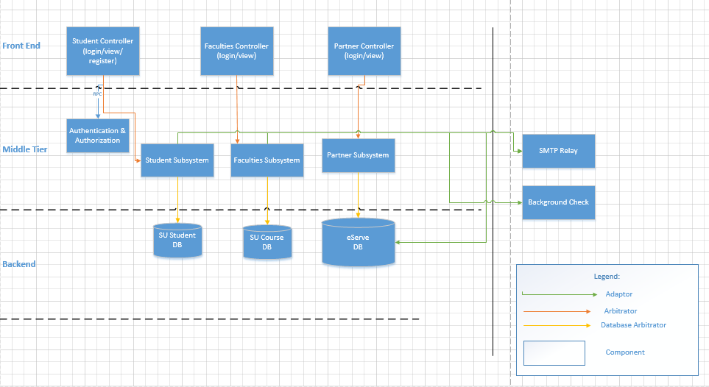

Process View:
The process view deals with the dynamic aspects of the system, explains the system process and how they communicate, and focuses on the runtime behavior of the system. Process view addresses concurrency, distribution, integrators, performance and scalability, etc.

UML Activity diagrams have been used to represent process view for different actors. Each process represents a set of sequential activities. The diagrams are free of any architectural style.
Diagram Rationale:
* At any instance there can be multiple user types (actors) accessing eServer system and each actor can access only a subset of all the components; hence we can divide the processes into
student process, faculty process, partner process, and administrator process.

* The process may also comprises of smaller tasks. For example an administrator may want to manage students, faculties as well as partners, thus representing distribution.

* Even though the activity diagrams have been split up, different process for different actors as well as same actors can run simultaneously allowing concurrency.

The following is process view.
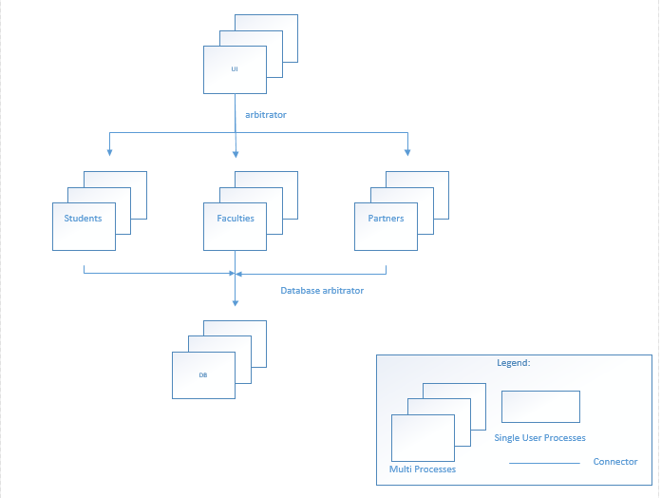

The following is student process view. It depicts the subsystems that a student would access in one session.
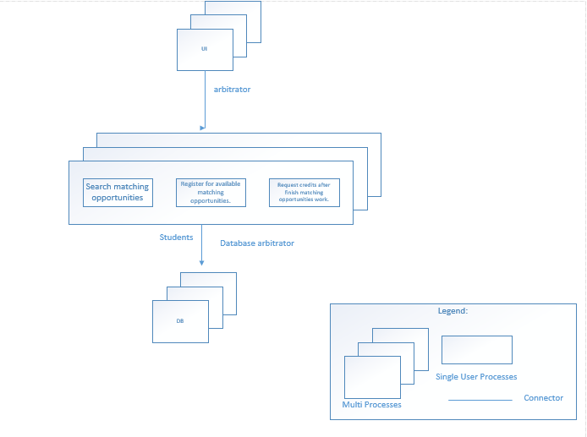

The following is faculty process view. It describes the subsystems that a faculty would access in one session.
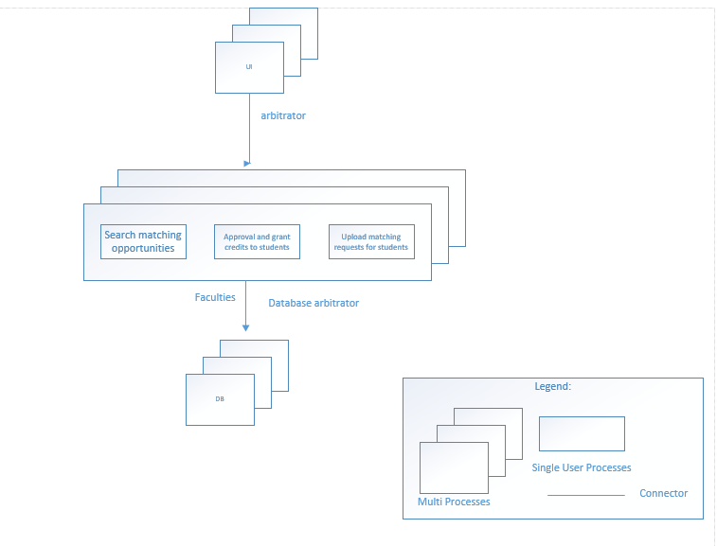

The following is partner process view. It dipicts the subsystems that a partner can acess in one session.

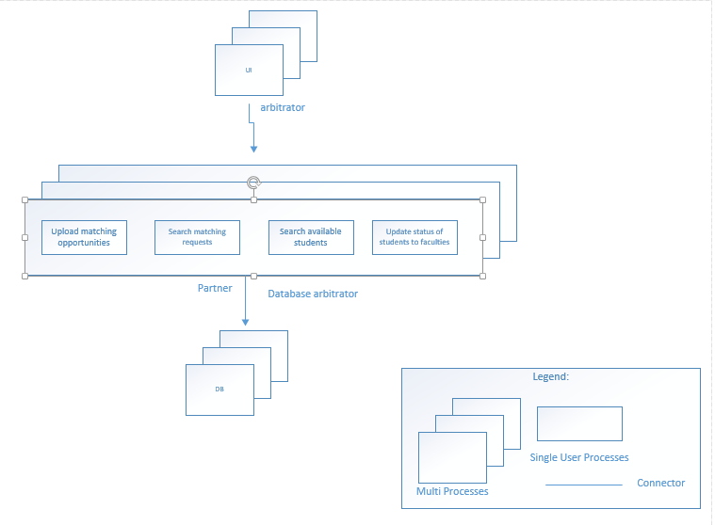

The following is administrator process view. It describes the subsystems that an administrator can access in one session.

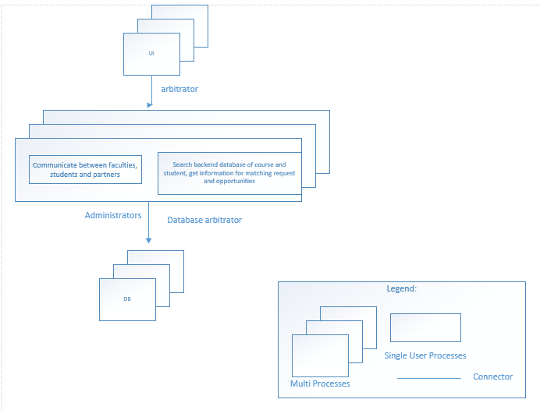

Physical View:
The intent of the physical diagram is to show a two data center 3 tiered system. The two DC’s will allow for distributed load and lower latency. Each DC is configured identical, and the DB’s have an optimized link between them running some form of syncing between the two, with Active/Active. Part of the set-up also allows for a parameter network for the frontend with firewalls separating the middle tier.

Front End

Group of servers that act as the webservers. They handle all the incoming user requests and interface with the middle tier. These servers would be in a Parameter network with Access to the DMZ. On the front end servers would be the controllers.

Routers and Firewalls

We have a couple of different routers in the system that distribute load. Each layer calls into a Router (BigIP) that will in turn load balance requests to the next tier town. We have firewalls at some of these routers to control access.

Middle Tier

Group of servers that act as the Interface to the DB’s and third party systems. The middle tier servers can all talk to each other. On these servers would be all subsystems.
Backend DB’s (Internal &external)
The backend DB’s would be the backend DB’s. These will store all data. The intent would be for all of these DB’s to be normalized and be optimized for Line of Business applications.

The following is physical view.

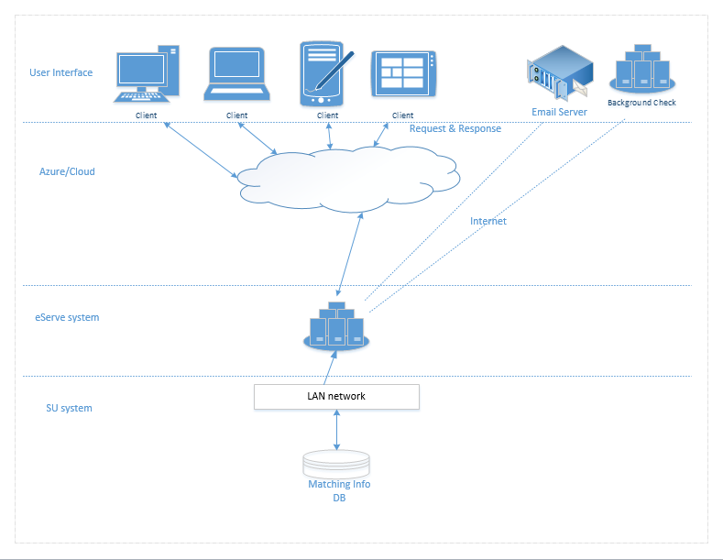

Development View:

The development view is the system architecture view from developer perspective. This view shows the basic requirements and work for the team. This development view uses layered style. This style can help the development team to understand the dependencies in the process.

The following is development view.

Development View
UI elements | - Design Forms for all web pages.
Interacting with web services/formatting for HTTPS protocol | - Formatting and packaging response.
Components & Subsystems | - eServe Community Benefit Functional areas: Processing logic for requirements.
Classes | - Classes for students, faculties, community partners and administrators.
Database elements | - Database access libraries to existing databases.

Scenarios:

Scenario View:

The description of an architecture is illustrated using a small set of use cases, or scenarios which become a fifth view. The scenarios describe sequences of interactions between objects, and between processes.

They are used to identify architectural elements and to illustrate and validate the architecture design. They also serve as a starting point for tests of an architecture prototype.

The below use case diagram describes the typical user activities performed in eServer system.

The following is scenario view.
